Tuesday, November 20, 2012

226 E. Flagler Street, Suite 200 For More Information:
Miami, FL 33131 Richard Kuper, Esq., Executive Director
(305) 416-4155 mdclc@bellsouth.net
www.mdclc.org
Press Release

MDCLC 6th Annual Turkey Drive

The Miami-Dade County League of Cities along with President Luis Gonzalez, the Board of Directors (elected officials) donors and volunteer students from Carol City Senior High School and Miami Norland Senior High School presented 1,000 families with items for a traditional Thanksgiving meal during this holiday season.

1,000 turkeys and 1,000 bags of non-perishable food items were given out Tuesday, November 13, 2012 to families that received a pre-distributed coupon.

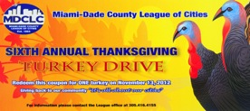

We would like to thank our sponsors Winn-Dixie Stores, Inc., Wells Fargo, City of Sweetwater, City of Hialeah Gardens, City of Doral and CAC-Florida Medical Centers
